artillery quick --count 50 -n 20 http://localhost:8081/info-sin > result_fork-sin.txt

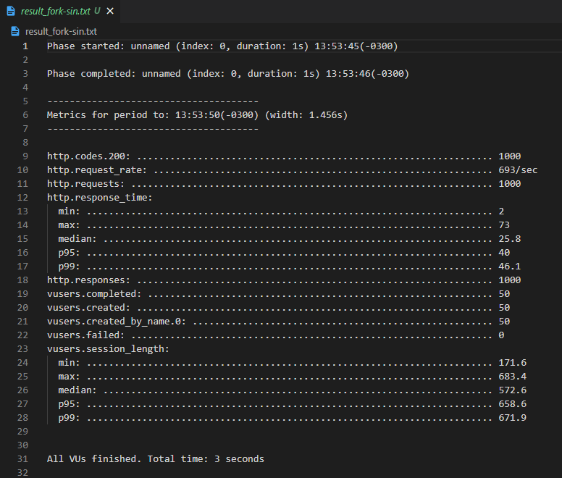

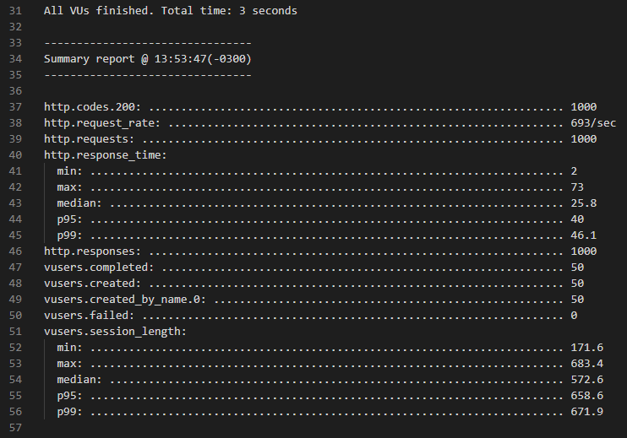

artillery quick --count 50 -n 20 http://localhost:8081/info-con > result_fork-con.txt

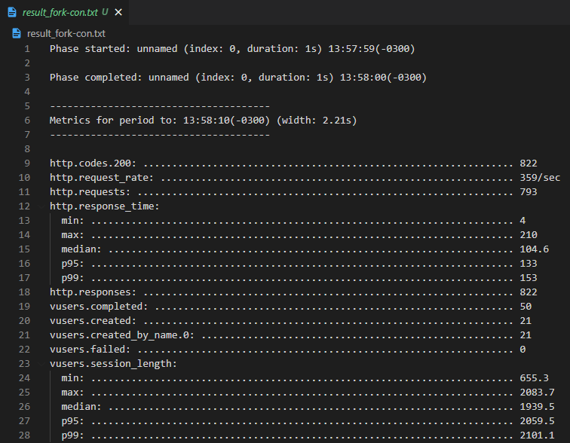

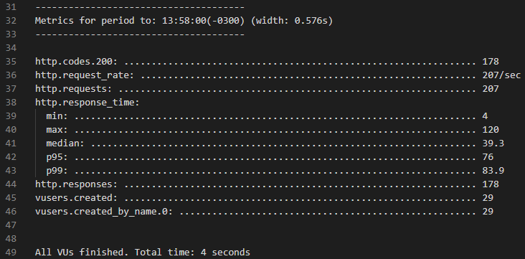

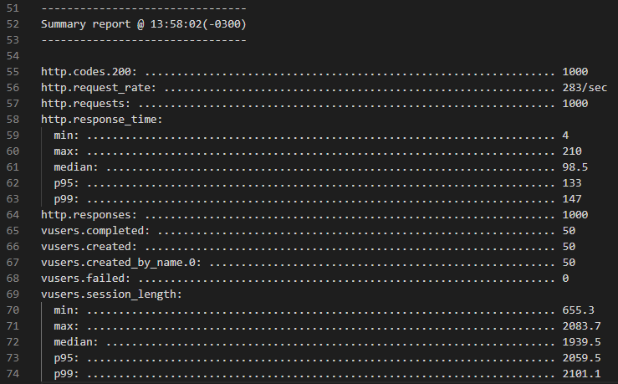

// NODE BUILT-IN PROFILER

// node --prof server.js



/ EN OTRA CONSOLA:

// artillery quick --count 50 -n 20 http://localhost:8081/info-sin > result_cluster-sin.txt

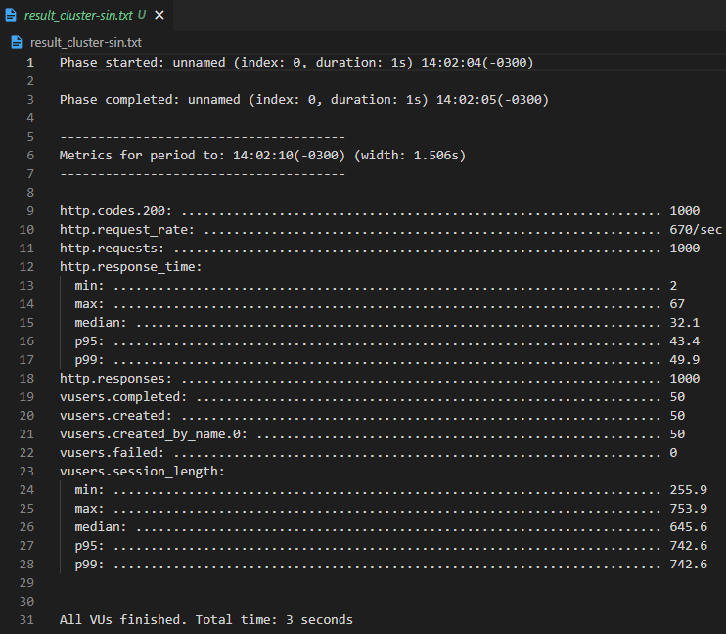

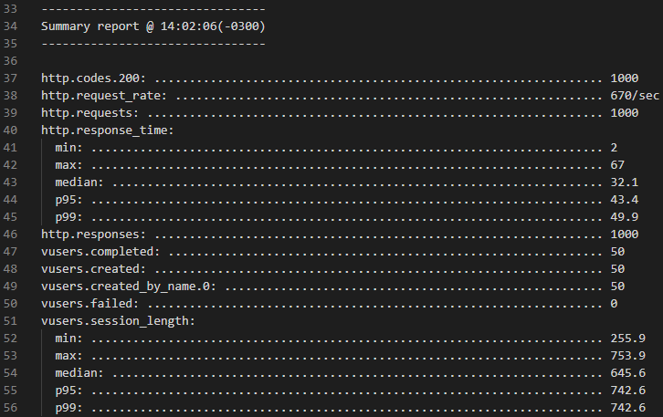

// EN OTRA CONSOLA:

// artillery quick --count 50 -n 20 http://localhost:8081/info-con > result_cluster-con.txt

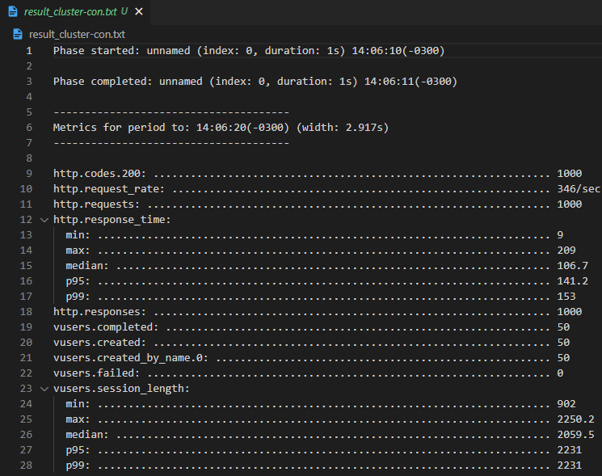

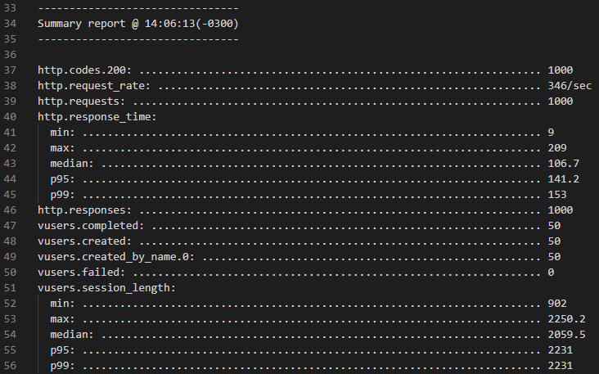

// node --prof-process sin-v8.log > result_prof-sin.txt

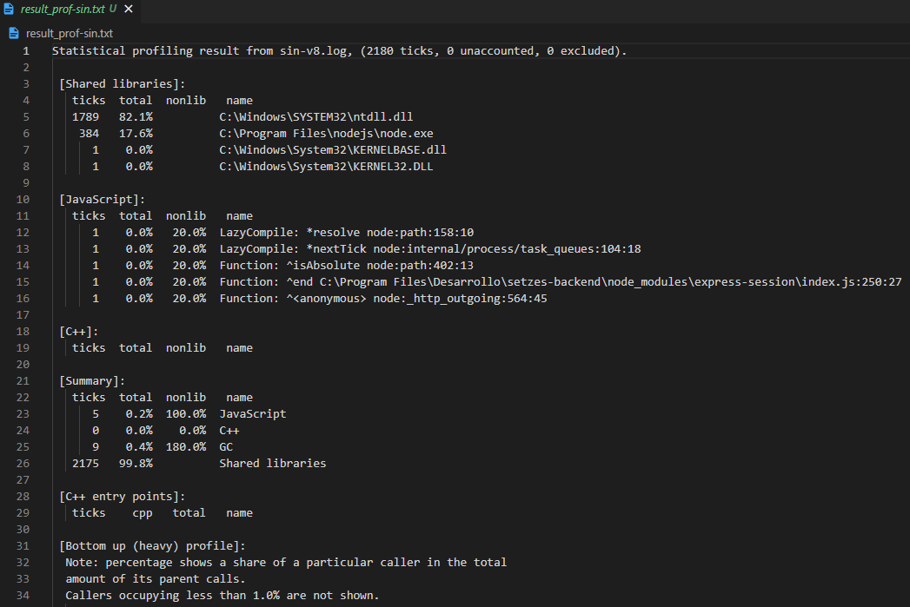

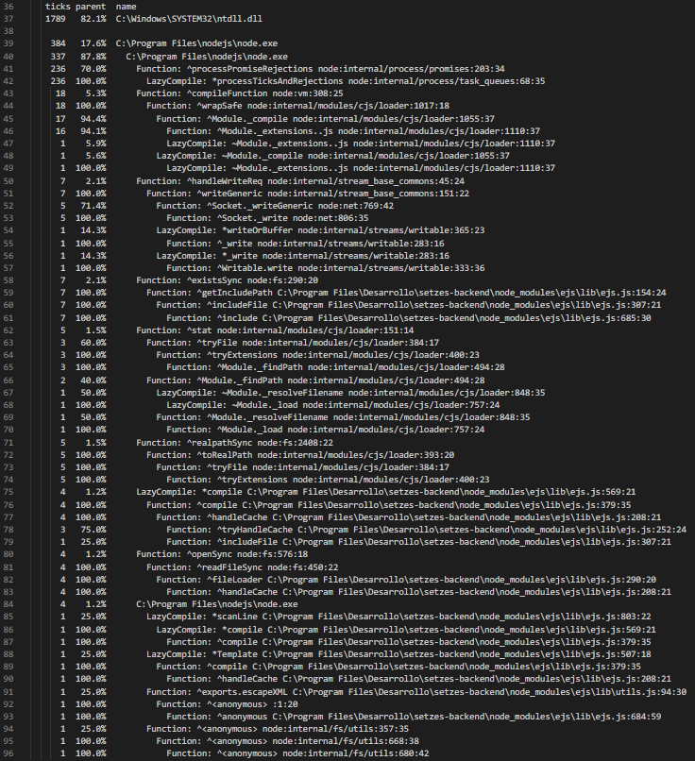

node --prof-process con-v8.log > result_prof-con.txt

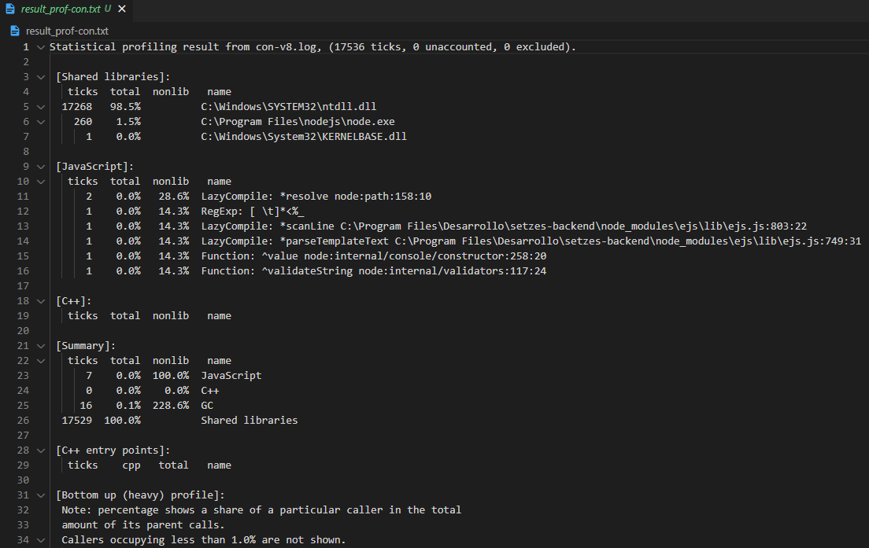

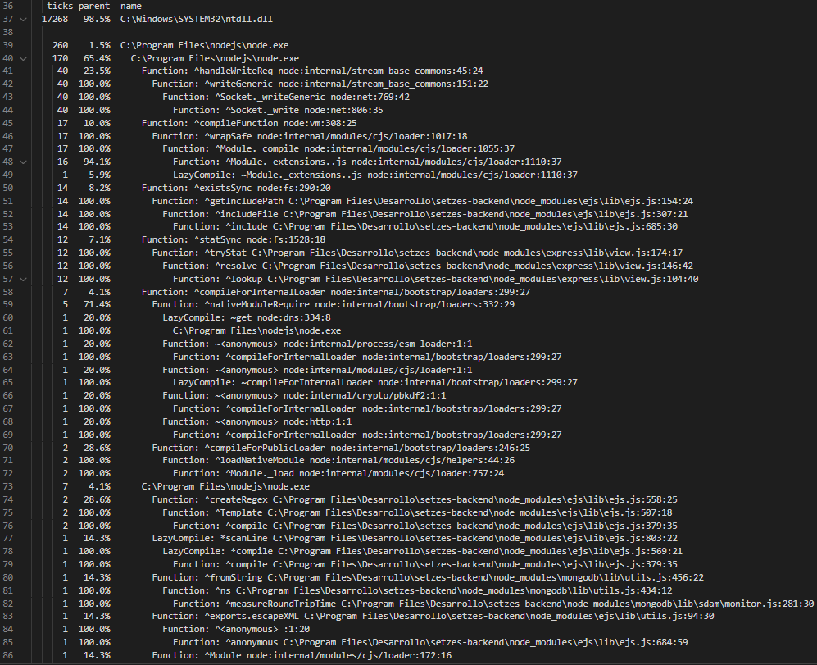

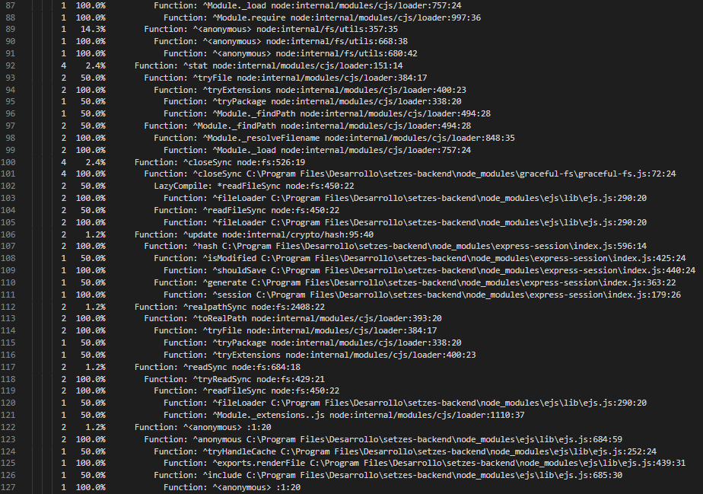

// MODIFICO package.json //

// "scripts": {

//   "test": "node benchmark.js",

//   "start": "0x server.js"

// }

// npm start

// EN OTRA CONSOLA:

// npm test

